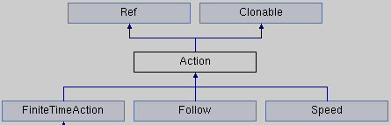
Action
Node *_target;

//returns a new action that performs the exactly the reverse action
virtual Action* reverse() const = 0;

virtual Action* clone() const = 0;/** returns a clone of action */

FiniteTimeAction
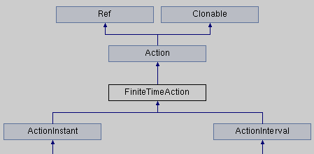
附加属性：
float _duration;

Speed
附加属性： 持续性动作的速度调节
float _speed;
ActionInterval *_innerAction;

Follow
附加属性： 追随

